POSITION PAPER
Simplification: from rhetoric to reality
Brussels, 31 August 2026
In line with the Better Regulation framework put in place in 2002, President von der Leyen unveiled in July 2024 a new strategy for regulating the single market, emphasising the streamlining of legislation and the reduction of administrative burdens. This led, a few months later to the presentation of several "Omnibus" packages. Even if these initiatives go in the right direction, they are not sufficient to compensate the continuous increase of legislative acts over the last 10 years.
Legislative activity has remained high despite the Commission’s simplification agenda. While the number of directives proposed declined from 185 per mandate (four years) under Barroso to 111 under Juncker before rising to 135 during Von der Leyen’s first mandate. The number of regulations shows a similar pattern: 645 under Barroso, 406 under Juncker and 416 during Von der Leyen’s first mandate. The same trend is observed for implemented acts, which reached a record of 1,204 (new and amending) in 2025, while only a slight decline was recorded in delegated acts.
This increase cannot be explained by an expansion of the Commission’s competences. Beyond the sheer volume of legislative acts, it is important to take into account the growing regulatory complexity and the level of detail in the various EU directives and regulations. This observation is supported by a 2025 study conducted for the European Parliament’s Policy Analysis Service. This analysis indicates that even if the number of new directives or regulations remains stable or decreases, individual acts can regulate matters in considerably greater detail and impose more extensive substantive and compliance requirements than before.
As a consulted European social partner, Ceemet has observed the same trend in the field of social policy, which has been subject to many directives over the last decade. The level of detail of EU text has also significantly increased, impacting more deeply the national level. This is the case for for example with the adoption of the Pay Transparency Directive. In January 2025, the Commission launched the Competitiveness Compass to reduce administrative burdens by 25% for all companies and 35% for SMEs. In February 2025the European Commission committed itself to reducing administrative burdens by 25%, corresponding to €37.5 billion in annual savings by the end of its mandate and came forward with the first Omnibus Simplification Package. In July 2025, the EU Parliament called the Commission to speed up the simplification process The European Commission reiterated the importance of simplification in its State of the Union address in September 2025. However, the Danish Presidency has warned that legislative proposals currently under negotiation could generate over €120 billion per year in additional compliance costs, based on the Commission's own impact assessments. This highlights a striking tension between the Commission's simplification agenda and the regulatory pipeline. Moreover, the first figures for 2026 show a still increasing legal density. We are far from the simplification for the companies, which have difficulties coping with the overall EU legal obligations. What companies expect from the EU is a real reduction of bureaucratic burdens and the creation of a business-friendly environment which would allow them to thrive and compete on the global market.
Therefore, Ceemet is convinced that European competitiveness and growth will be possible if, and only if, the EU:
- Implement Better Regulation principles and tools
The European Union has already defined Better Regulation as a set of principles and tools designed to ensure that EU policies and laws are prepared, implemented, and evaluated in an open, transparent, and evidence-based manner. Its primary goal is to achieve political objectives at minimum cost and administrative burden. It is now time to ensure full implementation of Better regulation principles by better using the following tools: 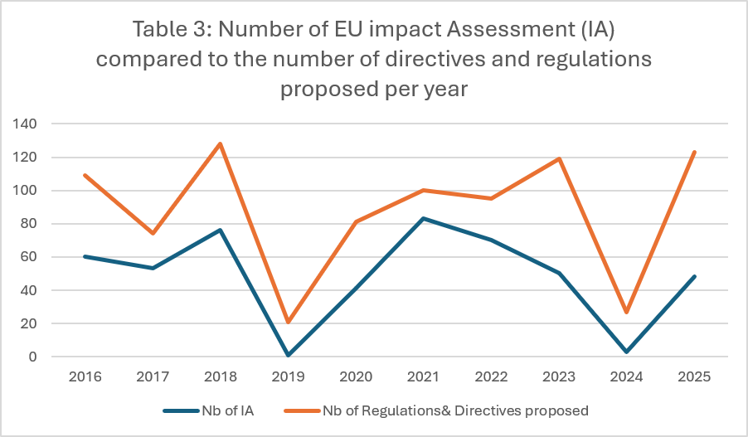

- The use of impact assessments to evaluate the economic, environmental, and social impacts of new initiatives before they are proposed.
In accordance with the “better regulation” principle, the Commission has committed to conducting impact assessments for major legislative initiatives. However, as the graph shows, the use of such assessments remains marginal, if not nonexistent, compared to the number of initiatives.
On 30 April 2026, the Cypriot Council Presidency published a paper on the legislative impact of EU legislation. According to that paper, only 49% of all legislative proposals currently going through the legislative process were accompanied by an impact assessment. Ceemet therefore calls on the Commission to systematically assess economic impact of all new legislation, including cumulative effects of proposed legislation in combination with other pieces of legislation. Impact assessments should be prepared independently and based on evidence. They should comprehensively capture the costs and administrative burdens imposed on both public authorities and private stakeholders. Indeed, as outlined in the Draghi Report, in 2020, only around 54% of impact assessments adequately considered the implications for SMEs, falling to 45% in 2021. Meanwhile, almost one third of the opinions issued by the Regulatory Scrutiny Board identified shortcomings requiring further improvement. In future, the Commission should adopt a regulatory approach that is proportionate and predictable, underpinned by rigorous impact assessments and a strict application of the "one in, two out" principle to avoid unnecessary cumulative regulatory burdens.
- The ex-post evaluation process is meant to ensure regular reviews of existing legislation to assess that it remains fit for purpose and facilitates compliance. This evaluation must be repeated at two stages during the process. Indeed, some legislative acts are subject to significant alterations because of the amendments adopted in trilogues. It would be useful to liaise as much as possible with business representatives during this ex-post evaluation phase to adjust standards or eliminate those that would create excessive administrative burdens or negatively impact business competitiveness. It is imperative that these evaluations be carried out systematically.
- The REFIT Programme (the EU's Regulatory Fitness and Performance initiative), which actively targets reducing regulatory burdens and administrative costs for businesses and citizens. However, since 2015 under REFIT, only 274 initiatives have been adopted, and 76 are pending adoption. Moreover, only 210 evaluations have been finalised. Compared to the numbers of legislatives acts proposed per year, these results are substandard and demonstrate the urgent need for the Commission to ensure that the principle of better regulation is a top priority. Ceemet reiterates the necessity to apply the REFIT agenda rigorously and consistently, with a clear focus on lowering regulatory burdens and compliance costs, especially for SMEs. To ensure that unnecessary costs are removed and rules are as effective and efficient as possible, the better regulation principle should be implemented at both the EU and national levels if policymakers wish to support MET industries and ensure the EU's competitiveness is maintained. In addition to implementing this principle, it is essential to withdraw proposals where the impact assessment shows net negative effects on competitiveness.
- Give up on plans for future burdens
Following an impact assessment, if it appears that the proposal results in the creation of new administrative burdens and procedures, it is imperative that the European Commission revise—or even discontinue—their plans. This could be the case for the envisaged "Quality Jobs Act" and, more broadly, for social policies. As indicated by the preliminary findings of the European Policy Innovation Council, DG EMPL has achieved 0.0%￼ of the implementation of the Draghi Report. Which objective is to restore European competitiveness and advocate for legislative simplification. Greater attention should be paid to respecting the limits of the EU’s competences and to avoiding unnecessary administrative burdens. This objective should also guide the implementation of legislation that is currently under negotiation or in the process of being adopted.
- Stop the implementation of already passed burdensome legislation
Alongside the need to improve both the quality of EU decision-making and the implementation of legislation, the Commission must also ensure that the existing legislative framework is simplified wherever appropriate. Continuing to implement legislation that imposes significant administrative burdens runs counter to the Commission's own objectives of regulatory simplification and restoring Europe's competitiveness. Rather than requiring legislative acts to be revisited shortly before they become applicable, unnecessary complexity should be addressed proactively.
In this context, the Commission's decision to "stop the clock" and reassess the sustainability reporting and due diligence requirements under the CSRD and the CS3D provided timely and necessary relief for businesses and opened the way for necessary changes of these pieces of legislation.

The same approach should now be applied to the Pay Transparency Directive. Ceemet therefore calls on the Commission to extend the deadlines for transposition and implementation of the Directive, creating the opportunity to review and recalibrate its requirements. Such a pause is essential to prevent disproportionate administrative burdens for both companies and national administrations, while ensuring that the legislation remains effective and proportionate. In particular, collective agreements resulting from negotiations between the social partners should benefit from a presumption of gender neutrality.

It is vital that the Commission not only halts anti-competitive implementation measures, but also focuses on adopting more simplification measures. This will ensure the creation of a single market that is more effective, more efficient, and fully aligned with the objectives of simplification, legal certainty, and competitiveness.

- Come up with more and effective simplification measures
In addition to monitoring the adoption of legislation, it is essential to also evaluate existing laws. Legislation that has not been of an impact assessment or an evaluation, simplification measures as a matter of priority. In this area, the easiest measures to implement concern regulatory overlaps, for example by eliminating duplicating reporting requirements or due diligence obligations. In a second phase, and based on the results of ex post evaluations, the Commission must propose omnibus legislation covering the remainder of existing laws. The field of social policy cannot remain a taboo for such evaluations! This is particularly relevant in the context of rapidly evolving technological advances and shifts in geopolitical dynamics, which are significantly impacting our economic and social environment. It is essential that our laws be adaptable and tailored to the needs on the ground.

Conclusion
Ceemet is calling on EU institutions to significantly reduce the number of new legislative proposals in order to establish a clear, enforceable legislative framework that supports European economic growth. It is also imperative that the Commission conduct impact assessments for all legislative proposals – before, during, and after adoption. Ceemet would like to call for the preparation of an annual report on regulatory burdens that compares actual reductions (not potential future reductions!) with actual new burdens. It is vital to demonstrate and ensure that the principle of better regulation is applied by making full use of all available tools.
Ceemet calls on the Commission and the Member States to redouble their efforts towards simplification. We consider that EU has the necessary tools and are well-versed in the established processes; the time has come to implement them in full. The succession of legislative proposals is not a sign of quality—on the contrary, MET companies expect politicians to demonstrate their seriousness and pragmatism through impact studies and evaluations conducted efficiently before, during, and after the decision-making phase.

Eurlex – Legal acts statistics, 2026
Eurlex – Legal acts statistics, 2026
Eurlex – Legal acts statistics, 2026
Table 1 and 2 are based on Eurlex – Legal acts statistics, 2026, with exclusion of Council regulations / directives.
Eurlex – Legal acts statistics, 2026 - These figures include proposed regulations and directives from the European Parliament and the Council, as well as regulations adopted by the Council.
European Parliament: Legislative complexity and monitoring the application of EU law, 2025
Eurlex, Communication from the Commission to the European Parliament, the Council, the EESC and the Committee of the regions A simpler and faster Europe: Communication on implementation and simplification, 11 February 2025
Financial Times, Denmark warns new EU red tape could cost €124bn a year, 15 September 2025
European Commission: Better regulation: guidelines and toolbox, 3 November 2021.
European Commission: Better Regulation,2026
2024 is a transition year where the flow of new legislative initiatives slowed down while the flow of evaluations of the performance of existing interventions increased in 2024. The Board scrutinised three impact assessments and 19 evaluations
Cypriot Presidency of the Council, Economic Impact of EU Legislation, Document 8299/1/26, p. 3. 2026
Publications Office of the European Union: REFIT Scoreboard – Justice, Consumers and Gender Equality (Policy Area 18); 2026
European Policy Innovation Council; Draghi Observatory, 2026

