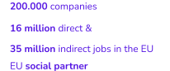
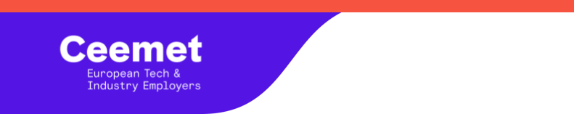

CALLING NOTE –163/26- 08/06/2026

28th CEG meeting
Copenhagen, 5-6 November 2026
Dear members,
In agreement with the Chair, Patrick Slaets, Ceemet is pleased to invite you to the 28th CEG meeting to be held on Thursday 5th of June 2026 from 12:00 to 19:00 with Orgalim and on Friday 6th from 9:00 to 15:00 in Copenhagen (Denmark) for Ceemet members only.

Venue

The CEG meeting will take place at the ofﬁces of DI - Danish Industry :
H. C. Andersens Blvd. 18, 1553 København, Denmark

Dinner on 5th of June 2026
Following the meeting, an informal dinner will be organised in common with Orgalim. The dinner will be held at 19:00. The location of the dinner will be communicated to you at a later stage.

Hotel Accomodation

Ceemet can suggest the following hotels which are located close to the ofﬁces of DI :

- Scandic Palace Hotel
Rådhuspladsen 57, 1550 København

- Radisson Collection Royal Hotel, Copenhagen
Hammerichsgade 1, 1611 København

- ProﬁlHotels Copenhagen Plaza
Bernstorffsgade 4, 1577 København




EU Transparency Register 61370904700-45
www.ceemet.org
secretariat@ceemet.org
38/40 Square de Meeûs, 1000 Brussels
@ceemet

- The Square
Rådhuspladsen 14, 1550 København

Agenda

The draft agenda for this meeting is attached (enclosure 1). Please let us know by 30 June 2026 CoB if you have comments on the agenda.

Conﬁrmation of participation

Please conﬁrm your participation at the meeting, dinner via this form by 30 June 2026 at the latest : 28th CEG Meeting - Copenhaguen – Fill in form

Best regards,
Patrick Slaets & Pauline Dubois-Graffin

Enclosure 1

Draft Agenda
Day 1 - 5 November 2026

- 12:00 - 12:10 - Registration & Welcome Coffee

- 12:10 - 12:20 - Opening Remarks (by Orgalim Chair and Ceemet Chair)

- 12:20 – National Development :
  - Austria (Orgalim)
  - Belgium Agoria
  - Denmark DI
  - Finland TIF
  - France UIMM
  - Germany Gesamtmetall
  - Germany Zvei
  - Germany VDMA
  - Netherlands FME
  - Portugal AIMMAP
  - Slovenia GZS
  - Sweden Tekniktoretagen
  - Türkiye MESS
  - UK Make UK

EU Transparency Register 61370904700-45
www.ceemet.org
secretariat@ceemet.org
38/40 Square de Meeûs, 1000 Brussels
@ceemet

- 17:00 – 17:20 Timeline for common data collection

- 19:00 – Dinner

Day 2 - 6 November

- 9:00-9:10 - Registration & Welcome Coffee

- 9:10-9:15 - Opening Remarks by Ceemet Chair

- 9:15- 9:20 – Election of the Chair

- 9:20 – 9:30 – Election of Vice Chair

- 9.30 – Discussion on Ceemet ﬁgures

  - Labour cost by Alexandre Jagot
  - Production by Susanna Aggeborn
  - R&D expenditures by Fhaheen Khan
  - Exports by Patrick Slaets
  - Productivity by Lars Kroemer
  - Employment by Lars Kroemer
  - Hours worked by Mark Spils
  - Investment by Hanne Mikkonen

- 11.30 – 13.00 – Discussion on Labour and skills datas

- 13.00 – 14.00 – Lunch

- 14.00 – 14.30 – Updates on Ceemet activities

- 14.30 – 15:00- Any other business

***

EU Transparency Register 61370904700-45
www.ceemet.org
secretariat@ceemet.org
38/40 Square de Meeûs, 1000 Brussels
@ceemet

